JOB SEQUENCING WITH DEADLINE

Problem Statement
- In job sequencing problem, the objective is to find a sequence of jobs, which is completed within their deadlines and gives maximum profit.
Solution
- Let us consider, a set of n given jobs which are associated with deadlines (d1, d2,...dn) and profit (p1,p2,...pn) is earned, if a job is completed by its deadline.
- These jobs need to be ordered in such a way that there is maximum profit.
- . It is also given that every job takes single unit of time, so the minimum possible deadline for any job is 1.
- How to maximize total profit if only one job can be scheduled at a time.

Here,
- We are given a set of jobs.
- Each job has a defined deadline and some profit associated with it.
- The profit of a job is given only when that job is completed within its deadline.
- Only one processor is available for processing all the jobs.
- Processor takes one unit of time to complete a job.

Approach to Solution-

- A feasible solution would be a subset of jobs where each job of the subset gets completed within its deadline.
- Value of the feasible solution would be the sum of profit of all the jobs contained in the subset.
- An optimal solution of the problem would be a feasible solution which gives the maximum profit.

Greedy Algorithm

- Greedy Algorithm is adopted to determine how the next job is selected for an optimal solution.
- The greedy algorithm described below always gives an optimal solution to the job sequencing problem.

Step-01:

- Sort all the given jobs in decreasing order of their profit.
Step-02:
- Check the value of maximum deadline.
- Draw a Gantt chart where maximum time on Gantt chart is the value of maximum deadline.

Step-03:

- Pick up the jobs one by one.
- Put the job on Gantt chart as far as possible from 0 ensuring that the job gets completed before its deadline.

Example

- Given the jobs, their deadlines and associated profits as shown-

Jobs | J1 | J2 | J3 | J4 | J5 | J6
Deadlines | 5 | 3 | 3 | 2 | 4 | 2
Profits | 200 | 180 | 190 | 300 | 120 | 100

Step-01:

- Sort all the given jobs in decreasing order of their profit-

Jobs | J4 | J1 | J3 | J2 | J5 | J6
Deadlines | 2 | 5 | 3 | 3 | 4 | 2
Profits | 300 | 200 | 190 | 180 | 120 | 100

Step-02:

Value of maximum deadline = 5.
So, draw a Gantt chart with maximum time on Gantt chart = 5 units as shown-

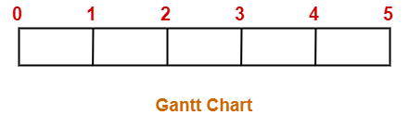

Now,
- We take each job one by one in the order they appear in Step-01.
- We place the job on Gantt chart as far as possible from 0.

Step-03:

- We take job J4.
- Since its deadline is 2, so we place it in the first empty cell before deadline 2 as-

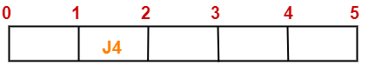

Step-04:

- We take job J1.
- Since its deadline is 5, so we place it in the first empty cell before deadline 5 as-

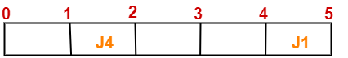

Step-05:

- We take job J3.
- Since its deadline is 3, so we place it in the first empty cell before deadline 3 as-

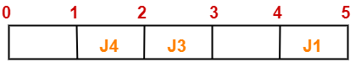

Step-06:

- We take job J2.
- Since its deadline is 3, so we place it in the first empty cell before deadline 3.
- Since the second and third cells are already filled, so we place job J2 in the first cell as-

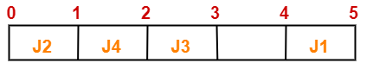

Step-07:

- Now, we take job J5.
- Since its deadline is 4, so we place it in the first empty cell before deadline 4 as-

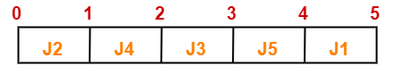

Now,
- The only job left is job J6 whose deadline is 2.
- All the slots before deadline 2 are already occupied.
- Thus, job J6 cannot be completed.

- The optimal schedule is-
{J2, J4, J3, J5, J1}
- This is the required order in which the jobs must be completed in order to obtain the maximum profit.
- Maximum earned profit
= Sum of profit of all the jobs in optimal schedule
= Profit of job J2 + Profit of job J4 + Profit of job J3 + Profit of job J5 + Profit of job J1
= 180 + 300 + 190 + 120 + 200=990 units

Example:
Let n = 4,
(P1, P2, P3, P4,) = (100, 10, 15, 27)
(d1 d2 d3 d4) = (2, 1, 2, 1).
Jobs(DECREASING ORDER OF THEIR PROFIT)=J1,J4,J3,J2
1 2
J4 | J1
TIMESLOT

FOR I=1 TO 4
K=MIN(DMAX,DEADLINE(1))=MIN(2,2)=2
K=2
WHILE K>=1
IF TIMESLOT[2] IS EMPTY
TIMESLOT[2]= JOB[I]

I=2
K=MIN(DMAX,DEADLINE[2])=MIN(2,1)=1
K=1
WHILE K>=1
IF TIMESLOT[1] IS EMPTY
TIMESLOT[1]=JOB[2]

SOLUTION={J4,J1}

Algorithm-1

    - The algorithm constructs an optimal set J of jobs that can be processed by their deadlines.

Algorithm GreedyJob (d, J, n)

// J is a set of jobs that can be completed by their deadlines.

{
J: = {1};
for i: = 2 to n do
{
if (all jobs in J U {i} can be completed by their dead lines) then
J: = J U {i};
}

}
Algorithm-2
Algorithm GreedyJob (d, J, n)
{
for i =1 to n do

Set k=min (Deadline (i), dmax)//Where Deadline (i) denotes the deadline of the i^{th} job
While k>=1 do
If timeslot[k] is empty then

timeslot [k] = job (i)
break
endif
set k=k-1
end while
end for
}

